Multiple-choice section – choose the correct answer

Question 1 [6.1]

What are the values of the pronumerals *s* and *t* in the following diagram?

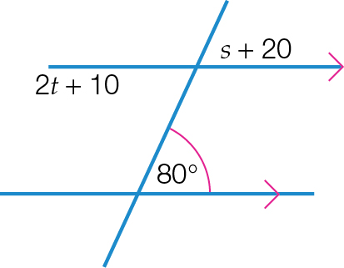

A 30°, 150°B 35°, 60°C 60°, 120°D 60°, 35°

Question 2 [6.1]

What is the value of *a* in the following diagram?

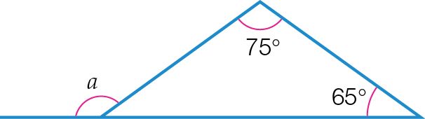

A 140° B 50° C 310° D 220°

Question 3 [6.2]

Which two triangles are congruent in the following diagram?

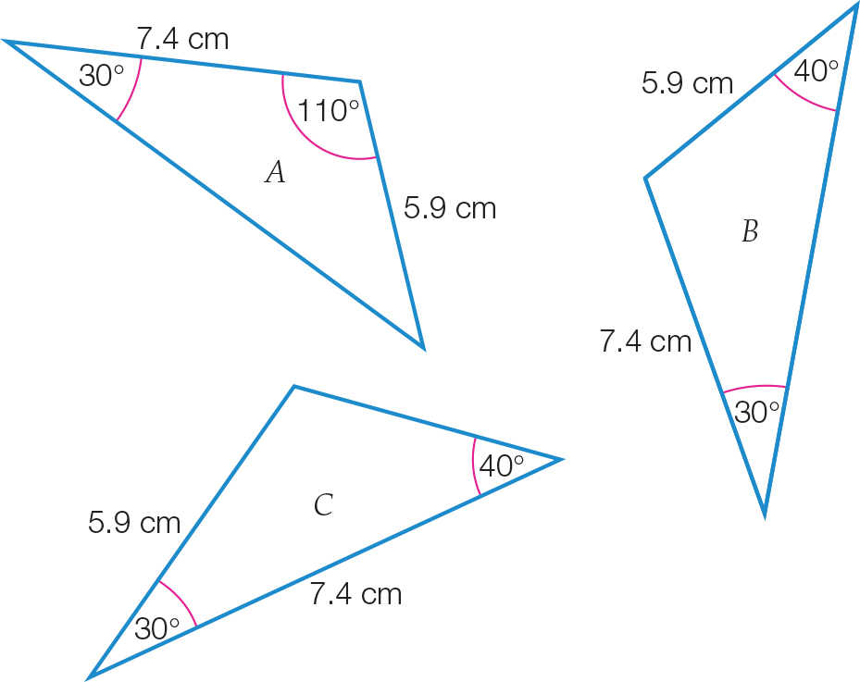

A Triangles *A* and *B*

B Triangles *A* and *C*

C Triangles *B* and *C*

D There is not enough information to decide.

Question 4 [6.4]

An equilateral triangle of side length 15 cm is reduced to become a triangle of side length 5 cm. The scale factor is:

A  B 5 C  D 15

Question 5 [6.3]

An angle in a parallelogram measures 113°. Another angle in this parallelogram is:

A 123.5° B 134° C 67° D 226°

Question 6 [6.7]

The following shape has:

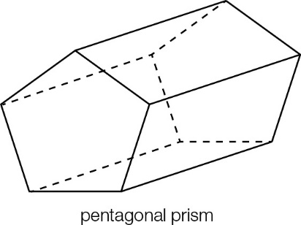

A 7 vertices, 10 faces, 15 edges **B** 10 vertices, 7 faces, 15 edges

**C** 15 vertices, 10 faces, 7 edges **D** 7 vertices, 15 faces, 10 edges

Question 7 [6.7]

A solid with two identical polygon ends and with a uniform cross-section is called a:

A prism B sphere C cone D pyramid

Question 8 [6.4]

∆*ABC* is reduced to ∆*A*′*B*′*C*′ using a scale factor of 0.5. If *AB* = 1.6 cm, then *A*′*B*′ is equal to:

**A** 3.2 cm **B** 2.4 cm **C** 1.6 cm **D** 0.8 cm

Multiple-choice results: ___ / 8

Short answer section

Question 9 3 marks [6.3]

Name each polygonandfind the values of the pronumerals for each.

**(a)**

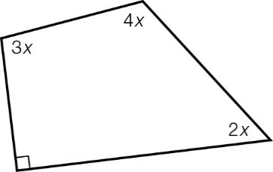

**(b)**

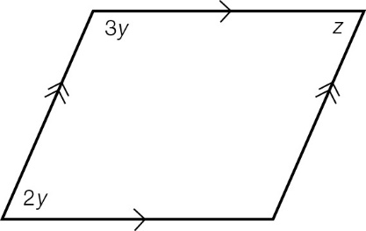

**(c)**

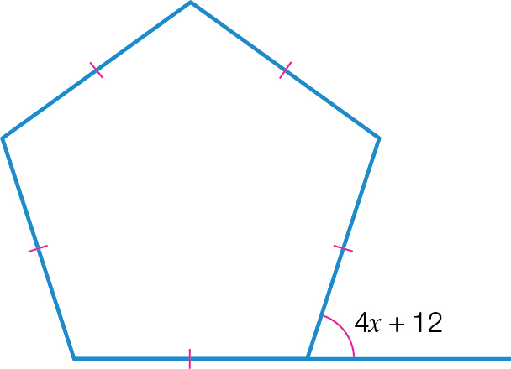

Question 10 6 marks [6.1]

Find the value of the pronumerals.

**(a)**

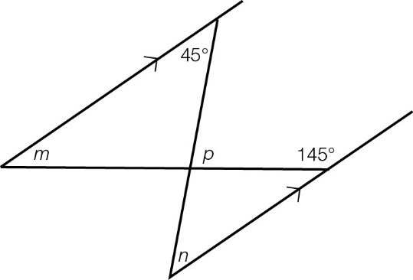

**(b)**

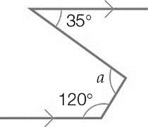

**(c)**

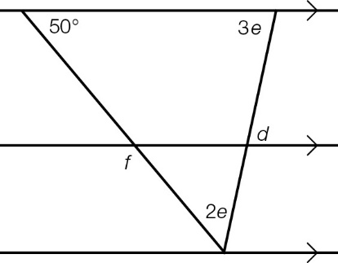

Question 11 3 marks [6.1]

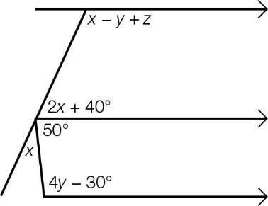

**(a)** Form an equation and solve it to find *x*. Give reasons for your answer.

**(b)** Form an equation and solve it to find *y*. Give reasons for your answer.

**(c)** Hence find the value of *z*.

Question 12 5 marks [6.2]

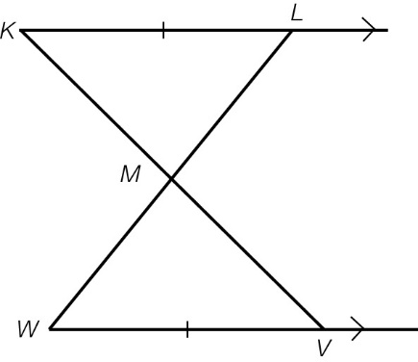

Complete the following proof by writing in the missing steps.

*KL* || *WV* and *KL* = *WV*. *KV* and *LW* intersect at *M*.

Prove that *KM* = *MV*.

Proof:

In ∆*KLM* and ∆*VWM*,

∠ ______ = ∠ ______ (alternate angles, *KL* || *WV*)

∠ _______ = ∠ _______ (vertically opposite angles)

________ = ________ (given)

∴ ∆ _____ ≡ ∆______ (ASA)

∴ ______ = ______ (matching sides of congruent triangles)

Question 13 2 marks [6.6]

Find the value of *y* in the following diagram.

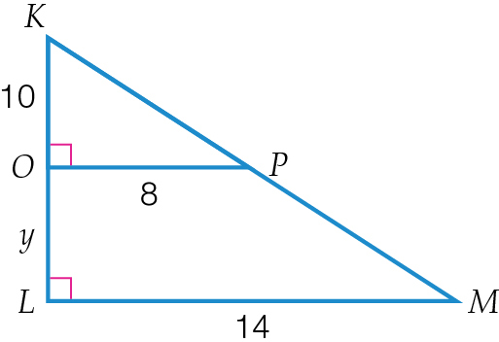

Question 14 8 marks [6.1,6.5,6.6]

Find the values of the pronumerals in the following diagrams.

**(a)**

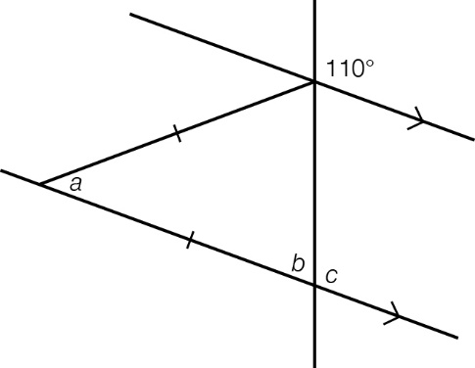

**(b)**

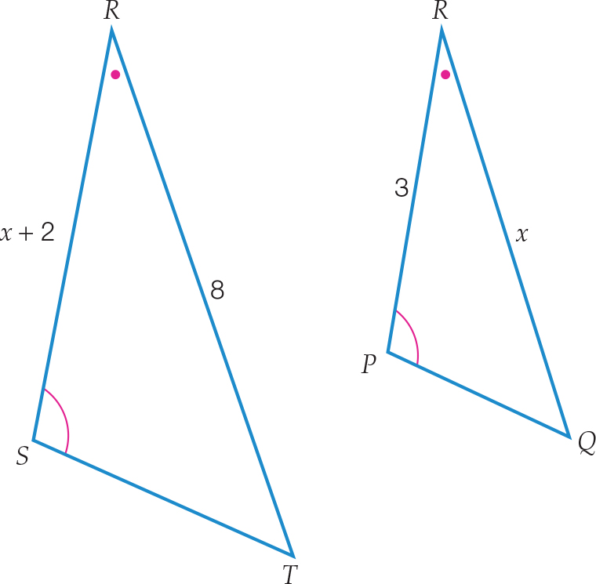

**(c)**

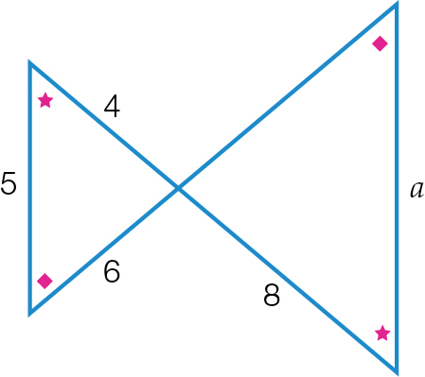

**(d)**

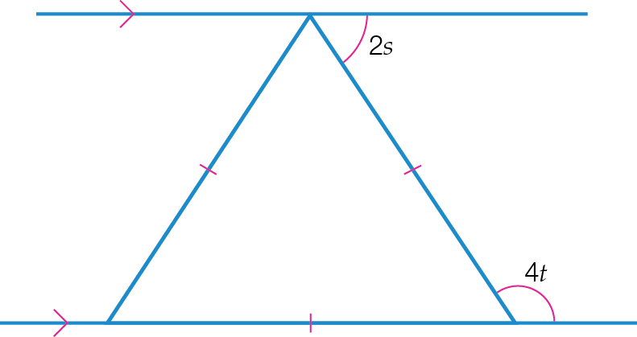

Question 15 3 marks [6.7]

Draw and label the net of this rectangular prism. Show all measurements.

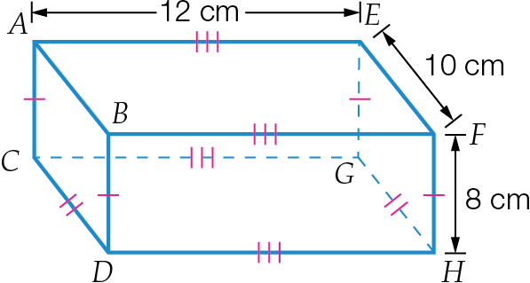

Question 16 2 marks [6.6]

Find the width *x* of the river in the diagram below.

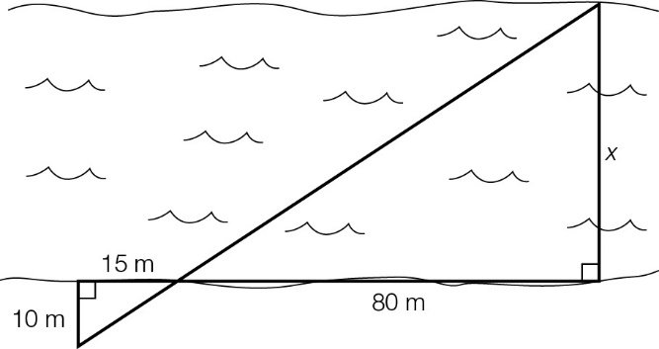

Question 17 5 marks [6.5]

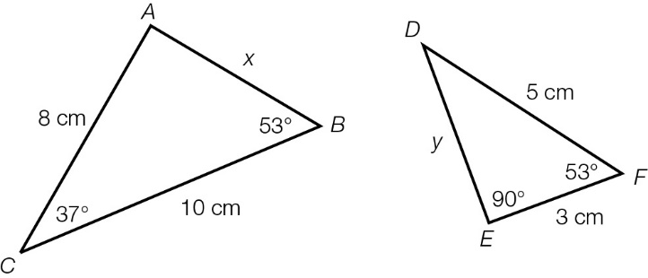

**(a)** Show that the triangles are similar.

**(b)** Hence find the values of *x* and *y*.

Question 18 2 marks [6.4]

The small pentagon has been enlarged to the large pentagon.

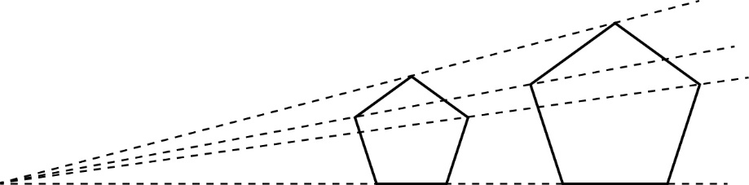

**(a)** By measuring the sides of each pentagon, determine the scale factor.

**(b)** What is the scale factor to reduce the larger pentagon to the small pentagon?

Question 19 4 marks [6.6]

Show that the two triangles are similar and then find the value of *z*.

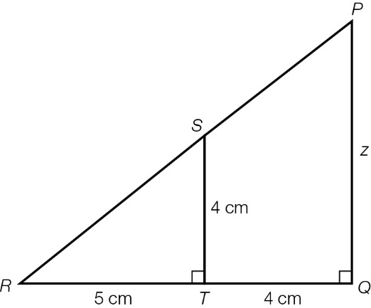

Question 20 3 marks [6.2]

Prove that ∆*DEH* ≡ ∆*GFH* and then find the value of *x*.

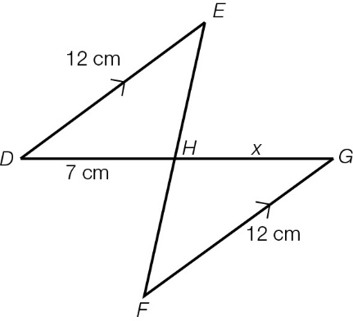

Question 21 3 marks [6.5]

∆*ABC* and ∆*KLM* are similar triangles.

∆*ABC* is shown here.

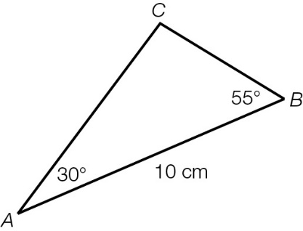

∆*KLM*: ∠*KLM* = 30°, ∠*LKM* = 95°, *LM* = 5 cm

Use this information to:

**(a)** determine the scale factor

**(b)** construct and correctly label ∆*KLM* to the correct scale, using a ruler and protractor.

Question 22 1 mark [6.4]

The area of a triangle is 45 cm2. What is the area of this triangle after the dimensions of the triangle have been reduced by a scale factor of ?

Short answer results: ___ / 50

Extended answer section

Question 23 9 marks [6.5]

*ABCD* is a quadrilateral in which the diagonal *AC* is drawn.

∠*BAC* = 40°, ∠*BCA* = 30°, ∠*ACD* = 40°, ∠*ADC* = 110°

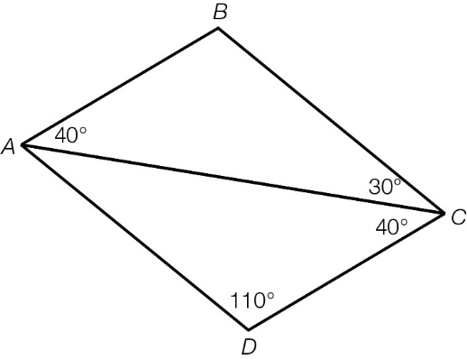

**(a)** Prove that ∆*ABC* is similar to ∆*CDA*.

**(b)** Is there enough information given to prove that ∆*ABC* ≡ ∆*CDA*? Give your reasons.

**(c)** Explain why *AB* || *DC* and *AD* || *BC*.

**(d)** What special quadrilateral is *ABCD*?

Question 24 2 marks [6.6]

Sofia designed a window frame for her new house. Find the length of the brace needed.

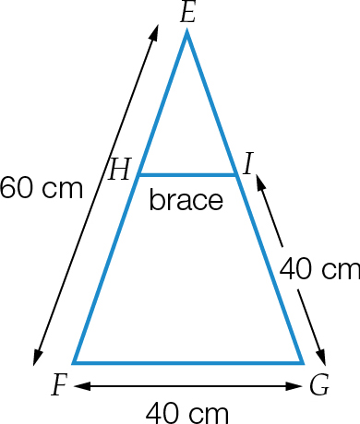

Extended answer results: ___ / 11

TOTAL test results: ___ / 69